
Year 8 Investigation 2 - Modified

Linear Models

Name: _______________________ / 33 marks

The school is planning a disco for all the year 9 students. It is your job to organize the music for the night. You have found the following 3 alternatives for the music.

Choice 1 - Rick’s Rock Group
Rick charges $100 per hour and but charges a flat fee of $20 for coming out

Choice 2 - Magic Mark DJ service
Mark charges $40 per hour plus a $200 flat fee.

Choice 3 - Steve’s Death Metal Band.
Steve charges $60 per hour plus a $100 flat fee.

- Complete the table of values for each option and write a rule using “C” for cost and “N” for Number of hours that could be used for each option. (8 marks)

Rick’s Rock Group
N (number of hours) | 0 | 1 | 2 | 3 | 4 | 5 | 6
C (cost in $) | 20 | 120

Now write a rule you can use to calculate the cost of Rick’s Rock Group.

$$C = ______ n + _______$$

Magic Mark’s DJ Service.
N (number of hours) | 0 | 1 | 2 | 3 | 4 | 5 | 6
C (cost in $) | 200 | 240

Now write a rule you can use to calculate the cost Magic Mark’s DJ Service.
$$C = _______ n + _______$$

Steve’s Death Metal Band.
N (number of hours) | 0 | 1 | 2 | 3 | 4 | 5 | 6
C (cost in $) | 100 | 160

Now write a rule you can use to calculate the cost Steve’s Death Metal Band.
$$C = _______ n + _______$$

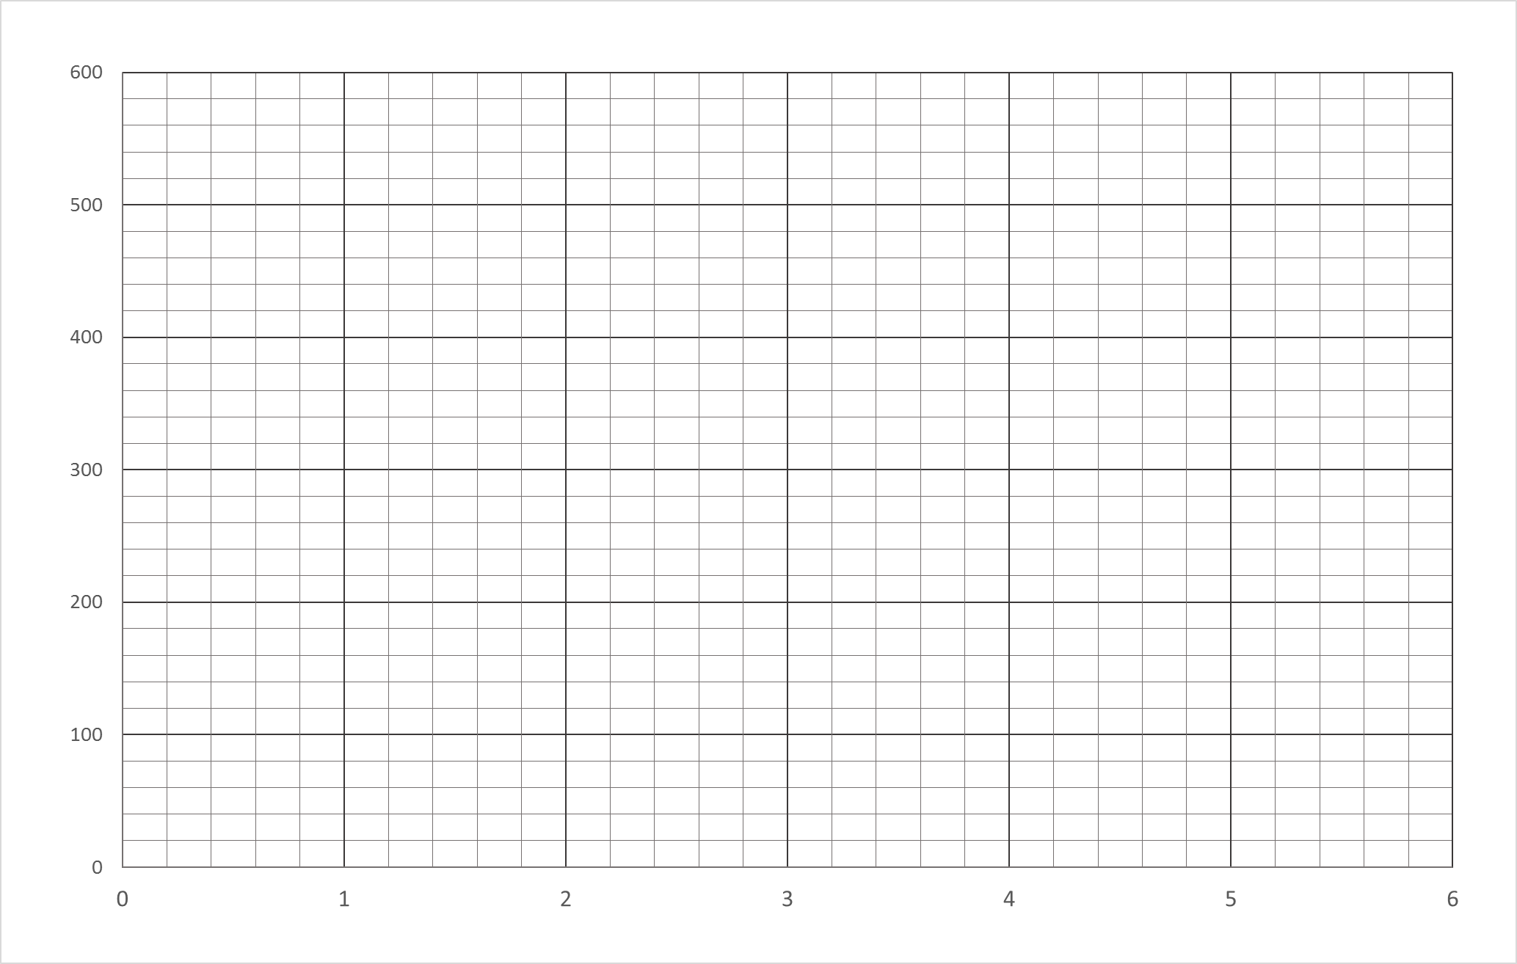

N (number of hours)

C (cost in $)

- Plot these three options on the graph paper provided. Label each option and the axes. (10 marks)

- Which music group is the cheapest in the first 2 hours? (1 mark)

- Which music group is the cheapest after 4 hours? (1 mark)

- Which music group is the cheapest after 6 hours? (1 mark)

- Which option is the best value if the disco is to go for 1 hour? (1 mark)

- How much will the cheapest music act cost if the disco goes for 4 hours? (1 mark)

- a) The principal has set the times for the disco from 7pm until 10:30pm (3.5 hours). Using your graph, find out what the cost would then be for each of the three options. (9 marks)

Rick’s Rock Group Magic Mark’s DJ Steve’s Death Metal

b) Check that these values are correct by substituting N (number of hours) back into your rule to find the cost. Show your working.

Rick’s Rock Group | Magic Mark’s DJ | Steve’s Death Metal
C = 100 ×_____ + 20  C = _________ + 20  C = $ _______ | C = 100 ×_____ + 20  C = _________ + 20  C = $ _______ | C = 100 ×_____ + 20  C = _________ + 20  C = $ _______

- If you are given a budget of $300, how many hours could you hire Magic Mark’s DJ service for? (1 mark)

